Graphing Homework
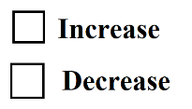  Market for Reserves  Administered Interest Rates  (Discount Rate and Interest on Reserves)  Policy Rate (Federal Funds Rate) | 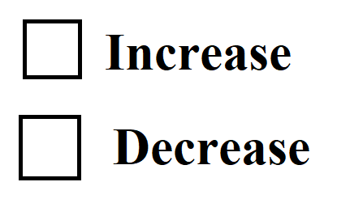  Consumption / Investment  Because of the ________ (lower/higher) Policy Rate, this will lead to a _____________ (increase/decrease) in interest rates in the economy.  Consumption  & Investment | AD/AS  The government is likely trying to address high ____________(inflation/unemployment).  The government is likely trying to address high ____________(inflation/unemployment).  Effect on AD (short run)?
Market for Reserves  Administered Interest Rates  (Discount Rate and Interest on Reserves)  Policy Rate (Federal Funds Rate) | Consumption / Investment  Because of the ________ (lower/higher) Policy Rate, this will lead to a _____________ (increase/decrease) in interest rates in the economy.  Consumption  & Investment | AD/AS  Effect on AD (short run)?
Show the effect on the Market for Reserves in an ample reserves economy.
Expansionary Monetary Policy
Contractionary Monetary Policy

